Product Details Portal.

# DESCRIPTION:

Create a servlet-based web application that shows a form to enter product details. Capture the details in a servlet and then display the data that was entered.

# Background of the problem statement:

As a part of developing an ecommerce web application, you have to prototype a form for adding products into the system entered by the users. There is no database involved here, so

the product is just captured and displayed without storing it anywhere.

**Used Application And Tecgnologies:**

* Eclipse as the IDE
* Apache Tomcat as the web server
* JSP pages for the front end
* Servlets for backend processing

# Flow Chart:

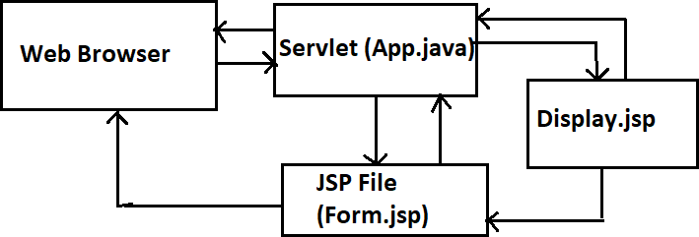

**Project Steps:**

* Created dynamic project.
* Creating servlet to put and store the data.
* The servlet will put the form data into the Product class and store it in the session.
* A second JSP will take the product info from the session and display it to the user.
* Run the Program on server and analyze the results.
* Clone the project to github